The Course Project

**Plagiarism and cheating will not be tolerated for this individual and independent project assignment. All submissions will undergo a thorough plagiarism check. Sharing your work with other students, copying others' work, or using AI tools such as ChatGPT is strictly prohibited. Any instances of plagiarism or cheating will result in a grade of 0 for the entire project submission.**

The course project consists of four parts. Parts 1, 2, 3 require the use of the project data zip file, while parts 4 require the use of a text file generated from part 3.

Part 1:

Develop a Mapper and Reducer application to calculate the *average* of *wind direction* (degree) for *each observation month* *from each year* (e.g. 195001) from NCDC records (note: 999 indicates missing value, and [01459] indicate good quality value).

***Commands:***

Making a directory in University Hadoop for project and its data

hdfs dfs -mkdir /home/24student24/Course_Project/

Unzipping the project data:

[student24@msba-hadoop-name ProjectData]$ gunzip *.gz

Copying the project data in Course_Project directory

hdfs dfs -copyFromLocal /home/student24/Project/ProjectData /home/24student24/Course_Project/

hdfs dfs -ls /home/24student24/Course_Project/ProjectData/

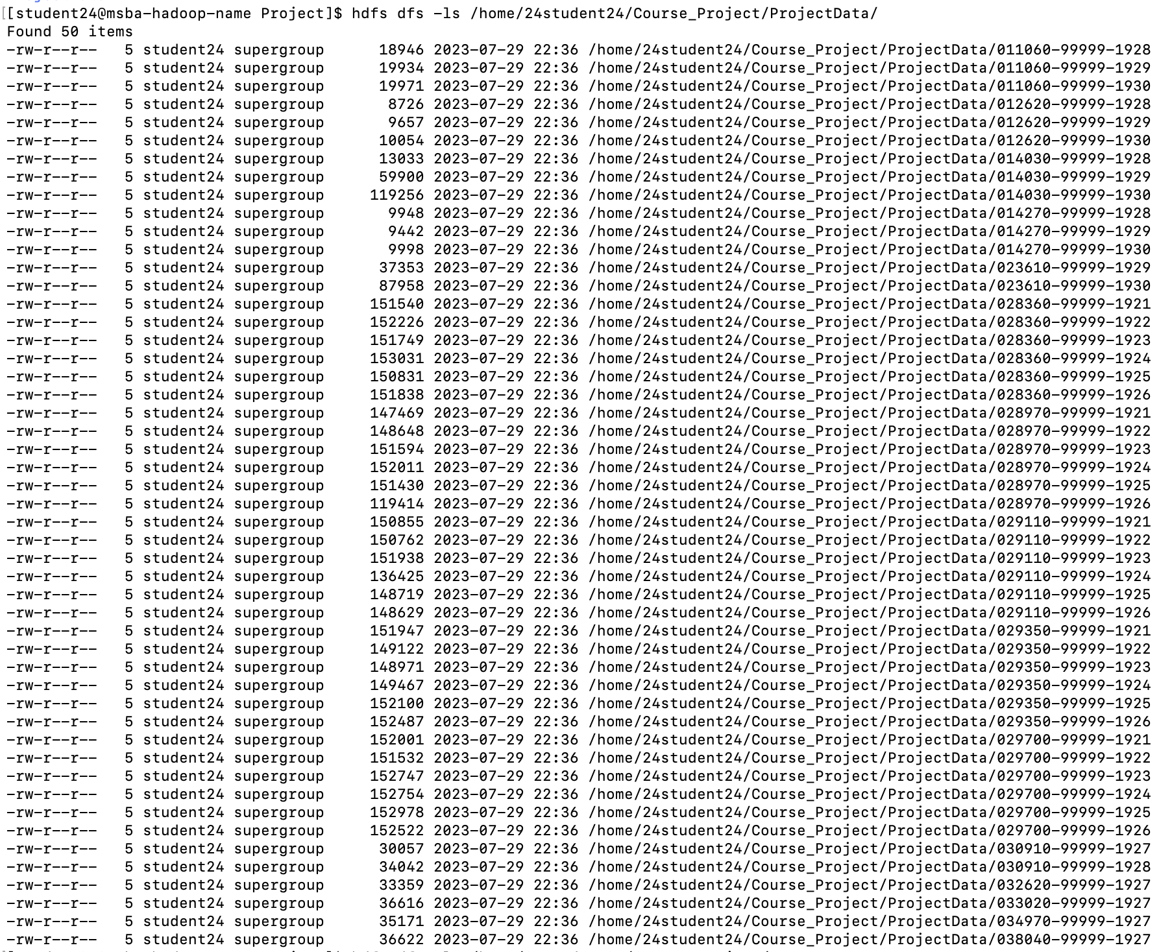

Checking the mapper and reducer .py files:

chmod +x part1_mapper.py

chmod +x part1_reducderr.py







Executing the Mapper and Reducer using Hadoop Streaming:

hadoop jar hadoop-streaming-2.7.3.jar -file /home/student24/Project/part1_mapper.py -mapper /home/student24/Project/part1_mapper.py -file /home/student24/Project/part1_reducer.py -reducer /home/student24/Project/part1_reducer.py -input /home/24student24/Course_Project/ProjectData/ -output /home/24student24/Course_Project/Part1_Output

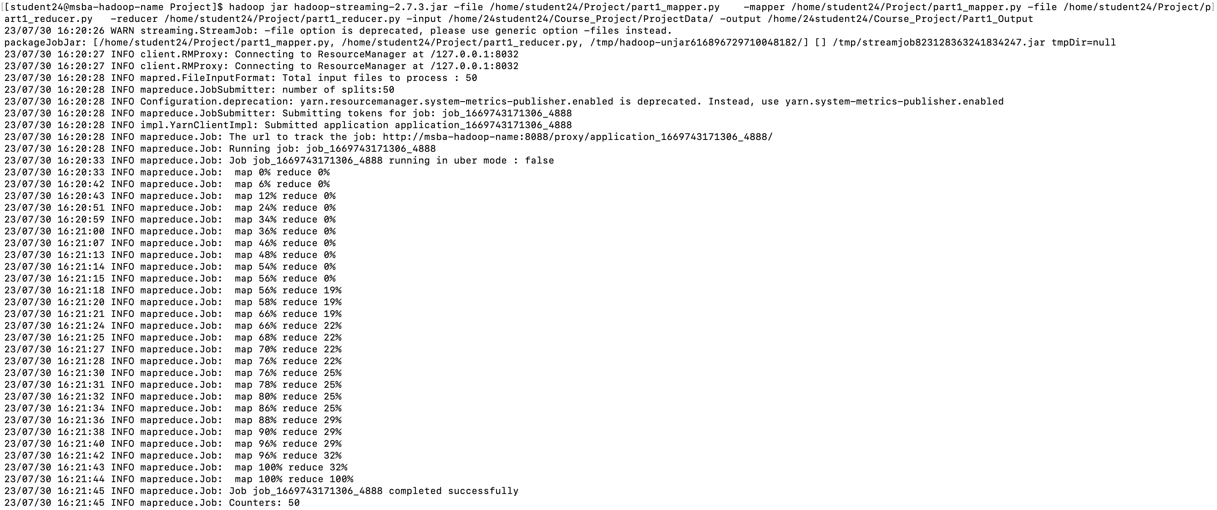

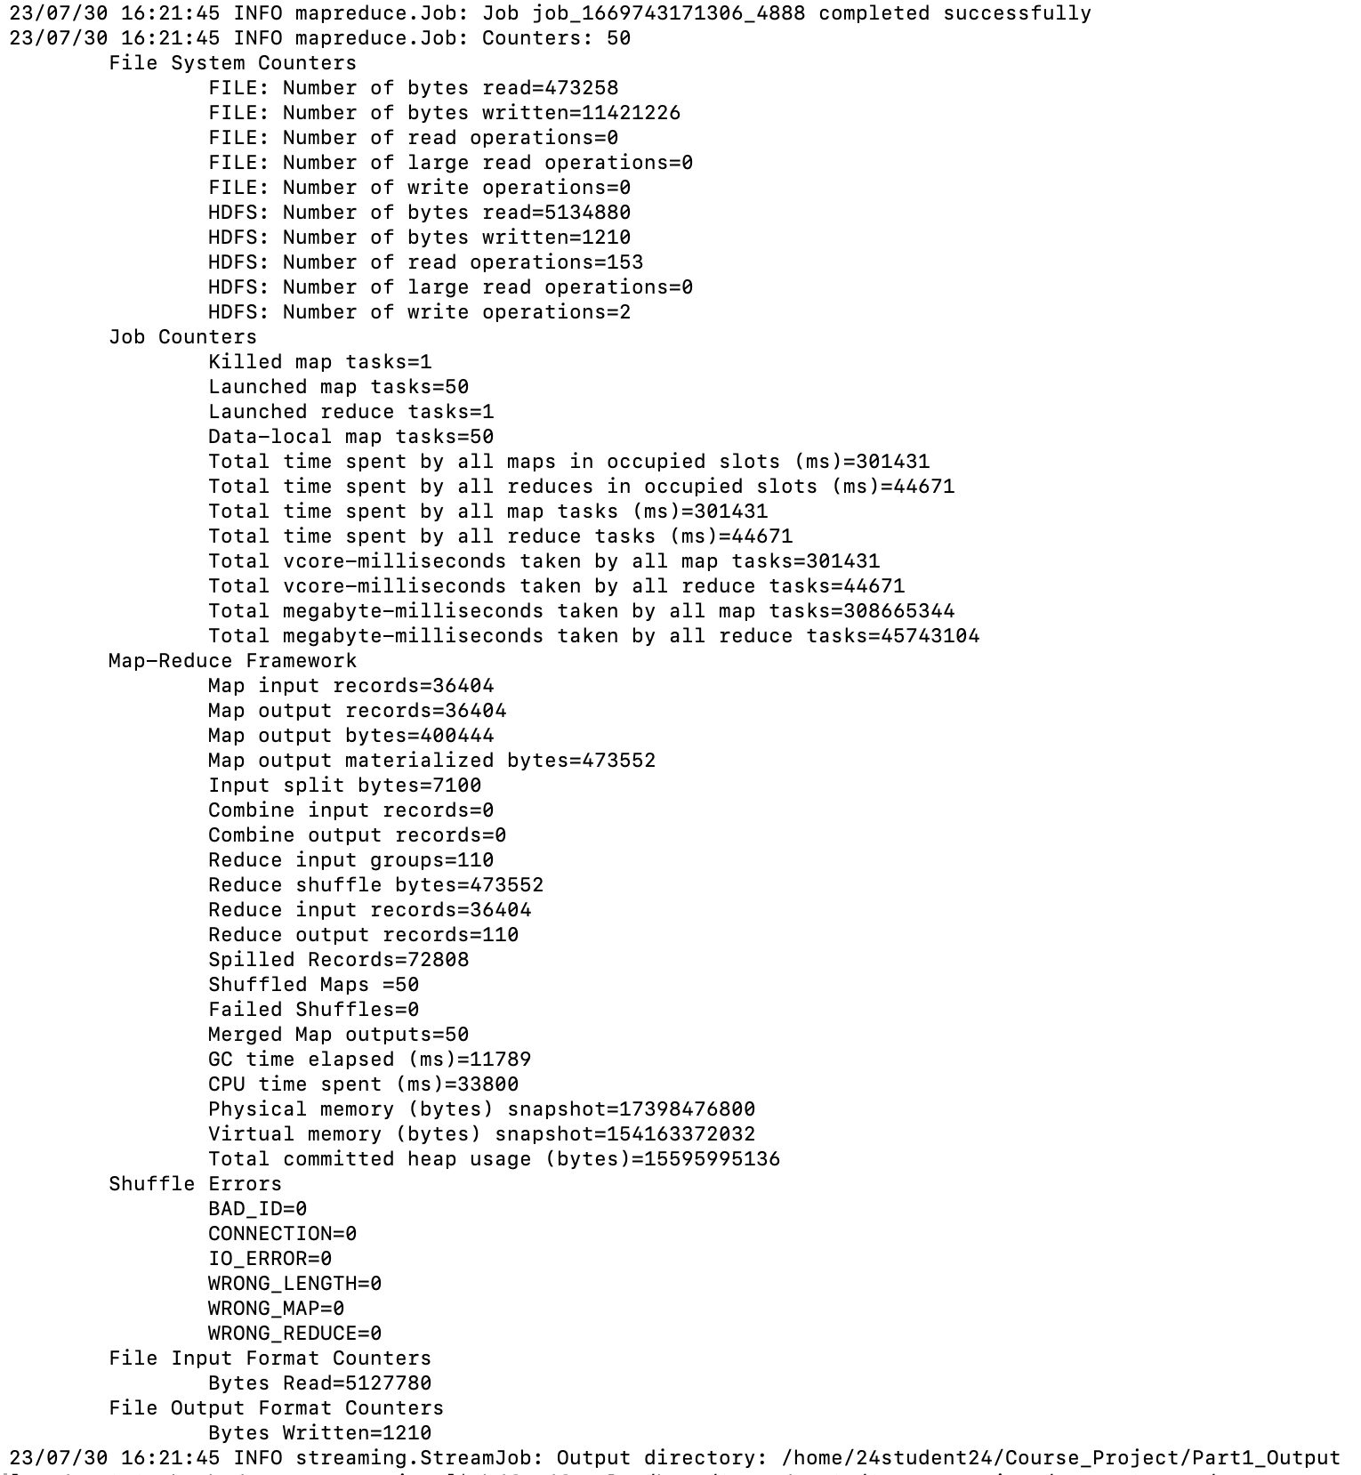

Output of part1:  
hdfs dfs -ls /home/24student24/Course_Project/Part1_Output/



hdfs dfs -cat /home/24student24/Course_Project/Part1_Output/part-00000/

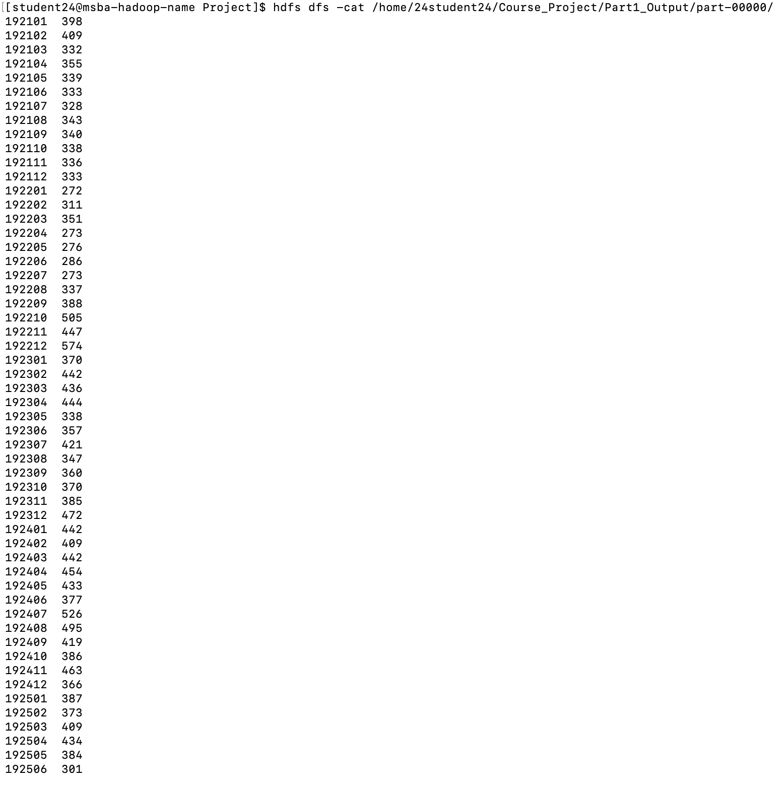

Part 2:

Develop a python application that can be implemented in PySpark to calculate the *range* (the difference between max and min values) of *sky ceiling height* (meters) for *each USAF weather station ID* from NCDC records (note: 99999 indicates missing value, and [01459] indicate good quality value).

***Commands:***

spark-submit --master local part2_PySpark.py

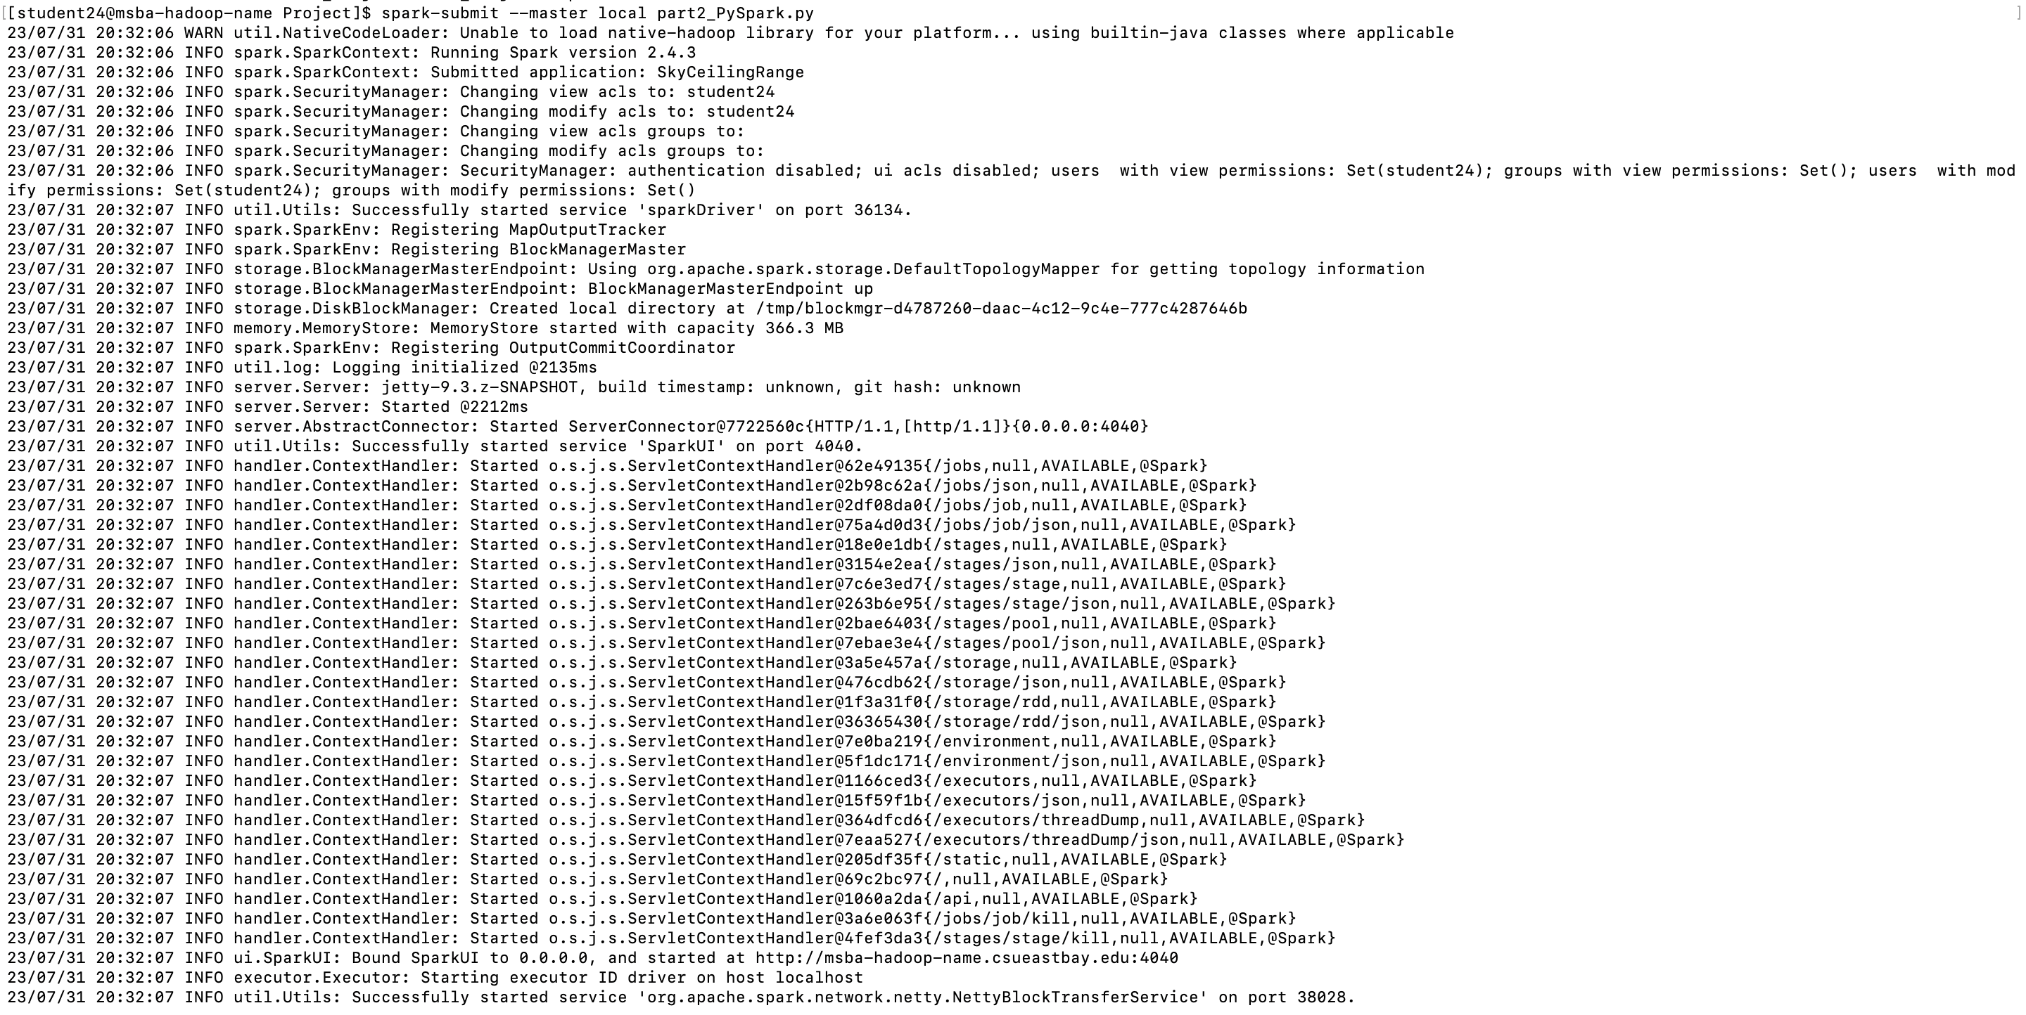

Checking the output for part2  
hdfs dfs -ls /home/24student24/Course_Project/Part2_ProjectOutput/

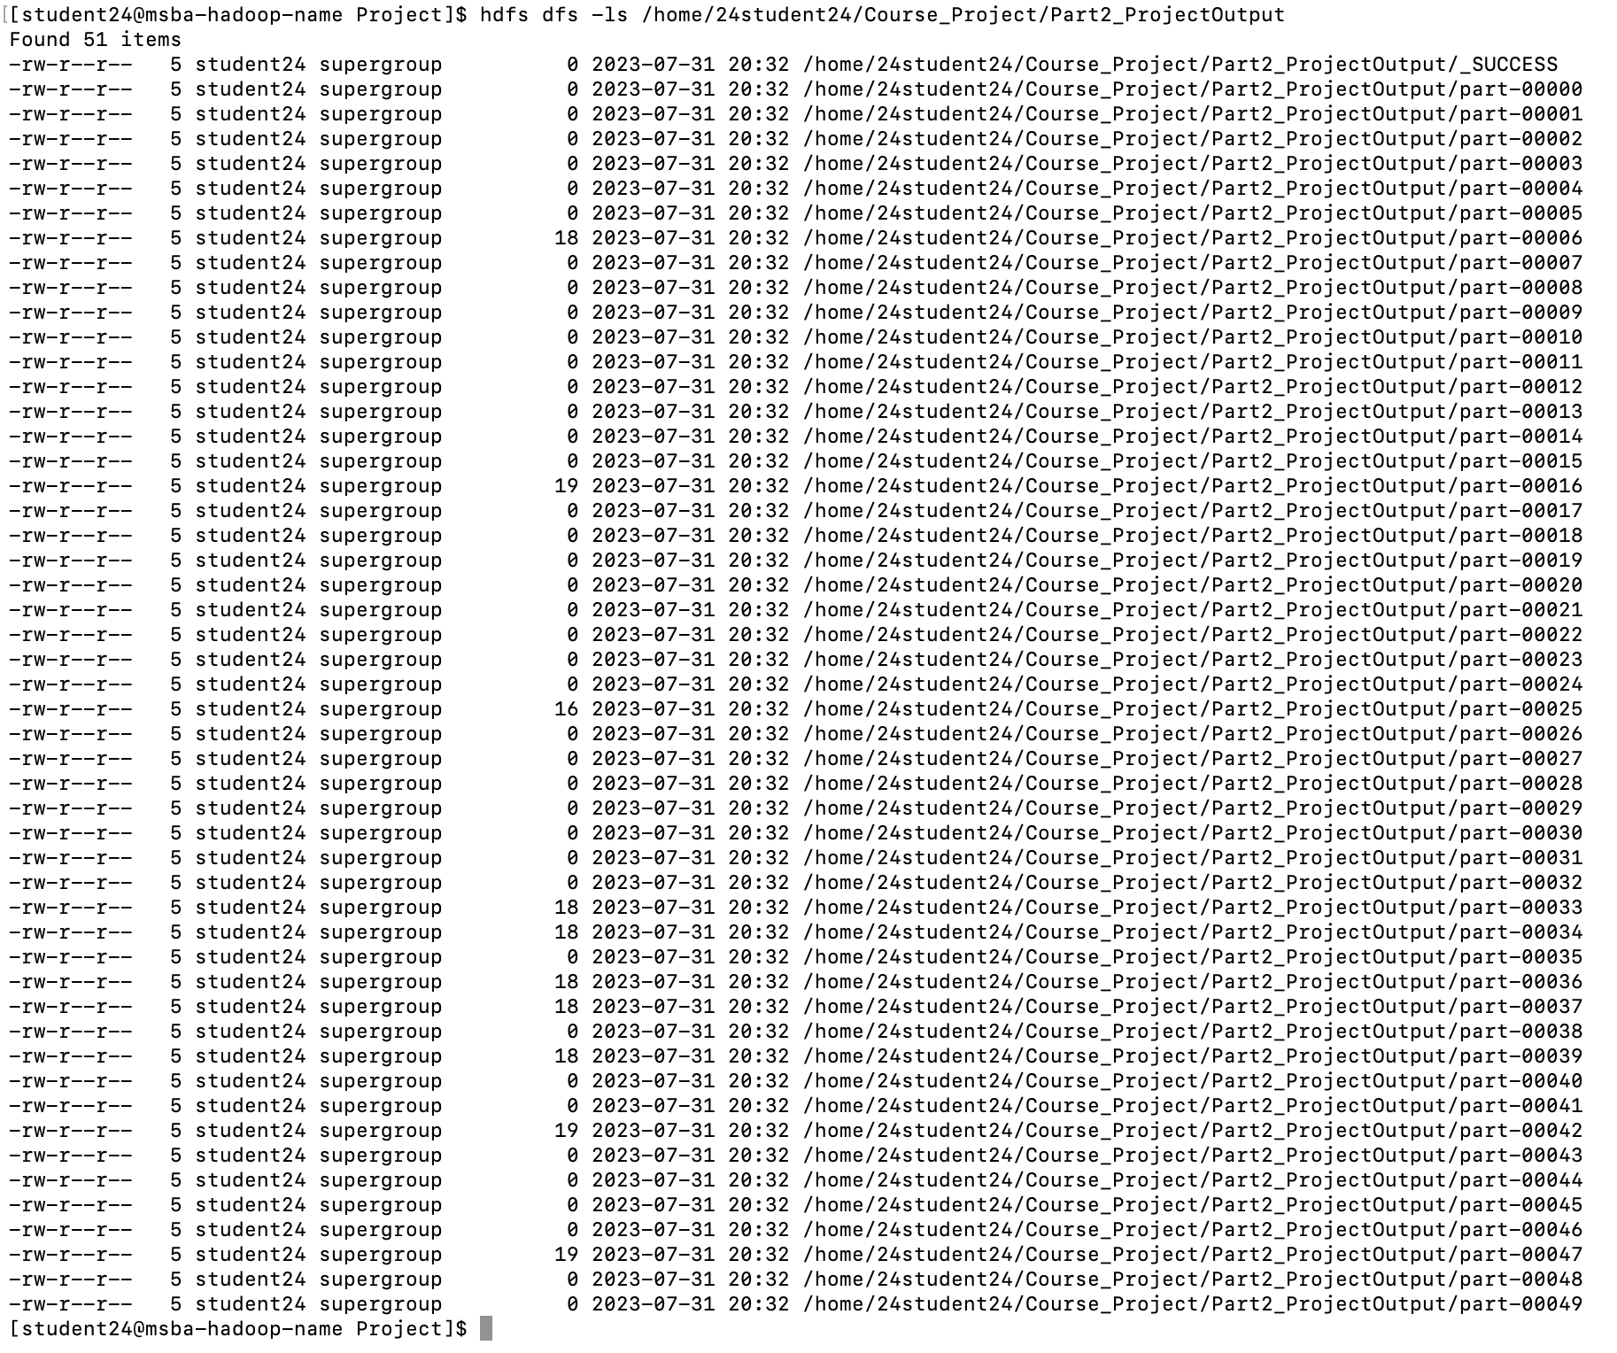

Printing the output of different output files:

hdfs dfs -cat /home/24student24/Course_Project/Part2_ProjectOutput/*

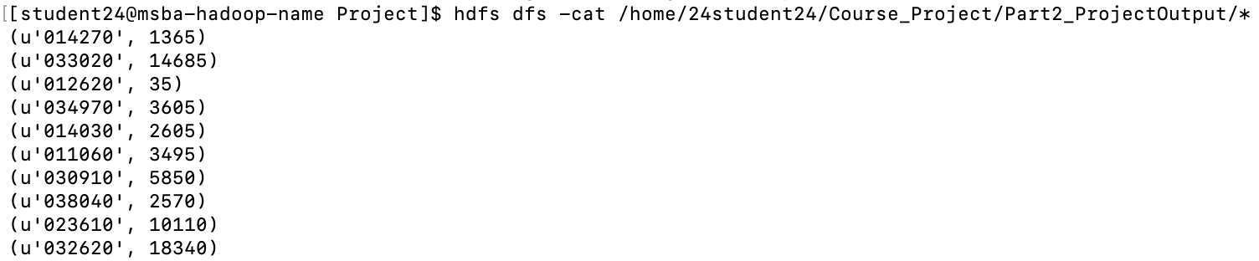

Part 3:

Develop a Mapper and Reducer application to retrieve *USAF weather station ID* and *visibility distance (meters)* from NCDC records (note: 999999 indicates missing value, and [01459] indicate good quality value) and then *write* the USAF weather station ID and visibility distance data into *a text file*.

***Commands:***

Using MRJob to run the file:

python part3_MRJob.py -r local ProjectData/*

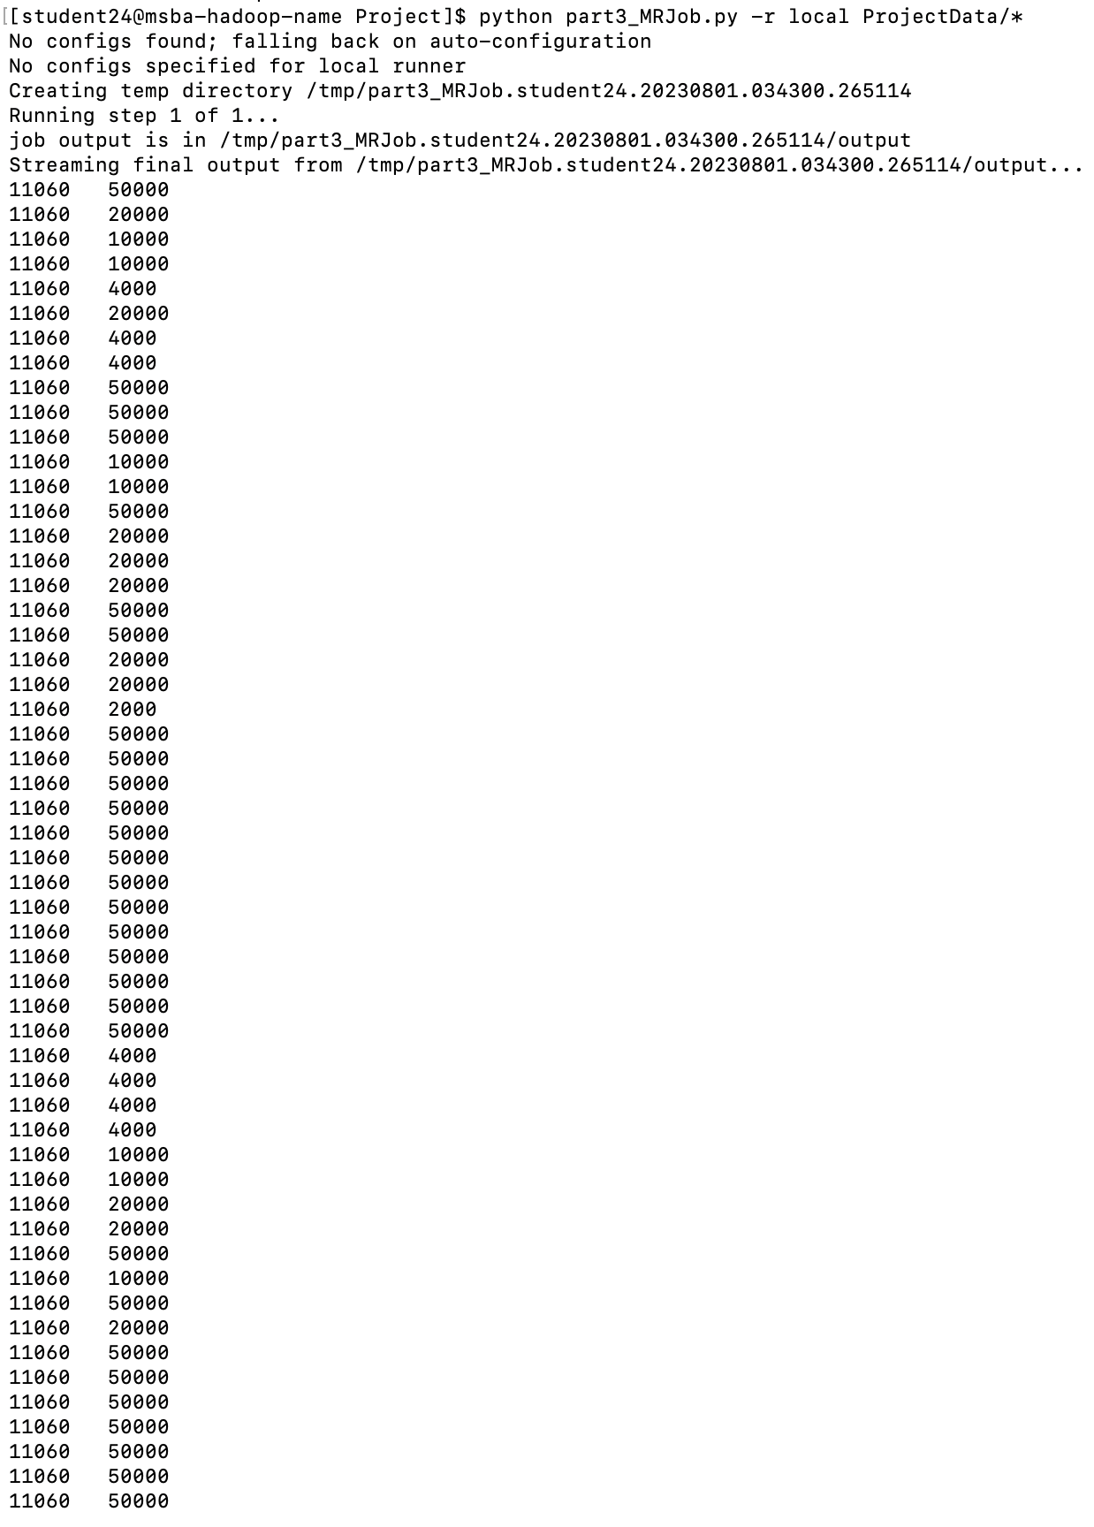

Converting output to .txt file

python part3_MRJob.py -r local ProjectData/* > Part3_ProjectOutput.txt

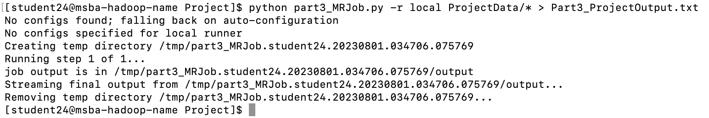

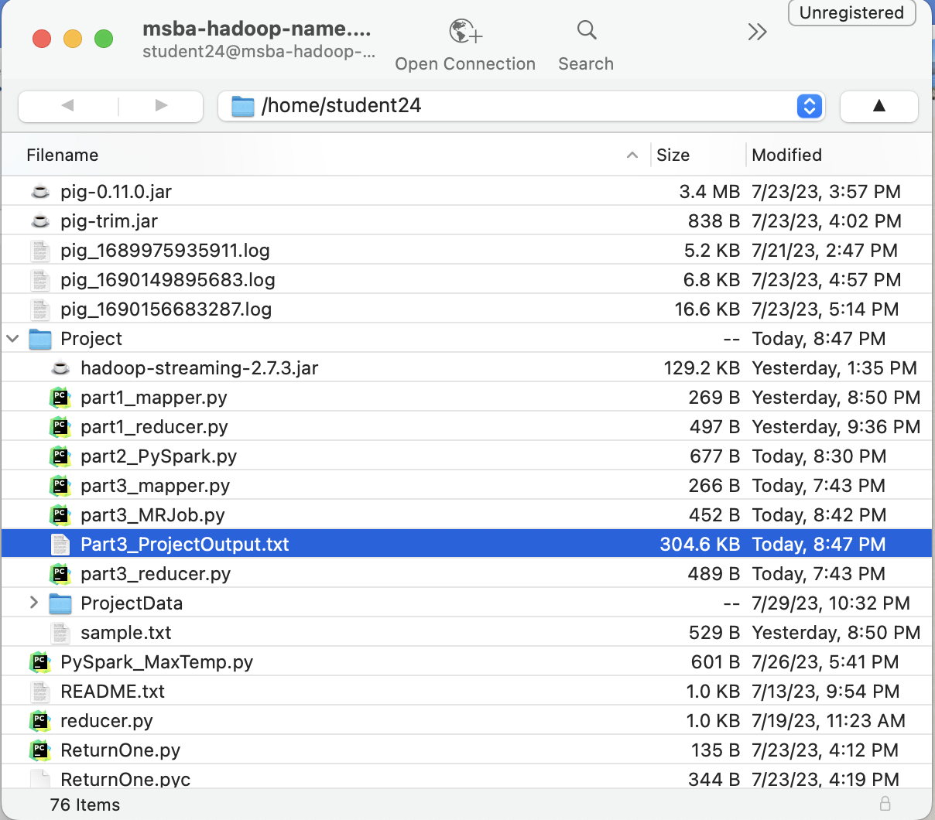

Part 4:

Load the text file into Pig and get the range of *visibility distance* for each USAF weather station ID.

***Commands:***

Initiating pig

pig -x local

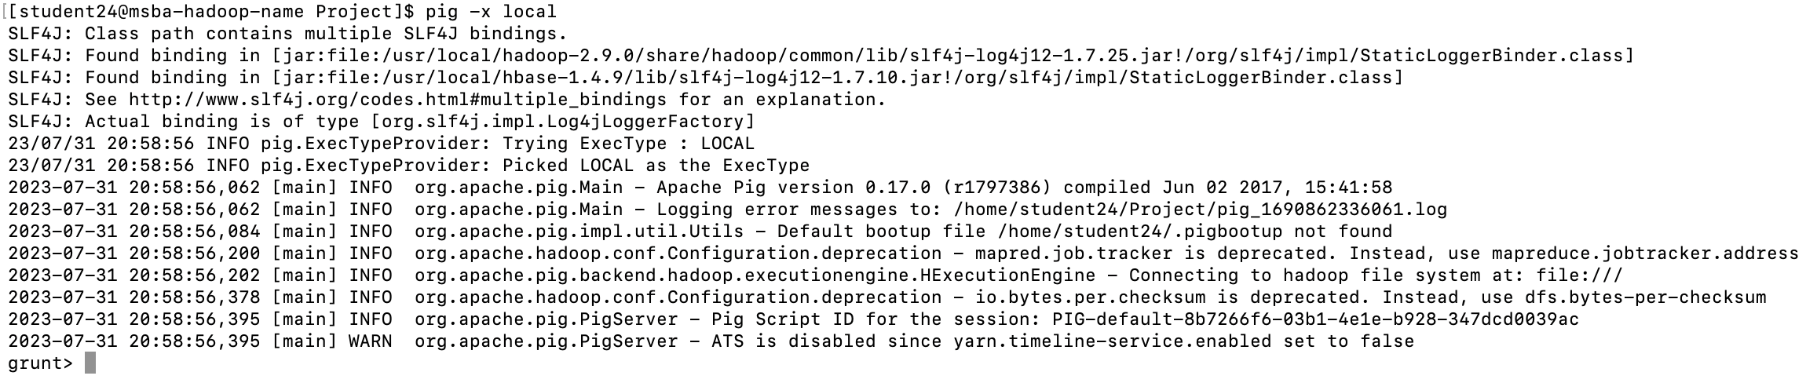

Loading the created Part3_ProjectOutput.txt file into pig

Visibility_Distance = LOAD 'Part3_ProjectOutput.txt'

AS (usaf_id:int, visibility_dist:int);



Using DUMP

DUMP Visibility_Distance;

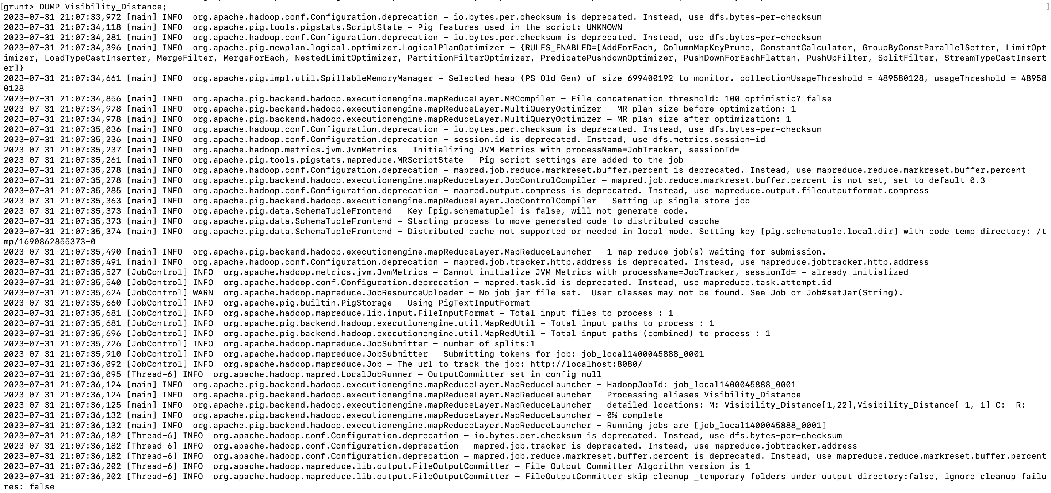

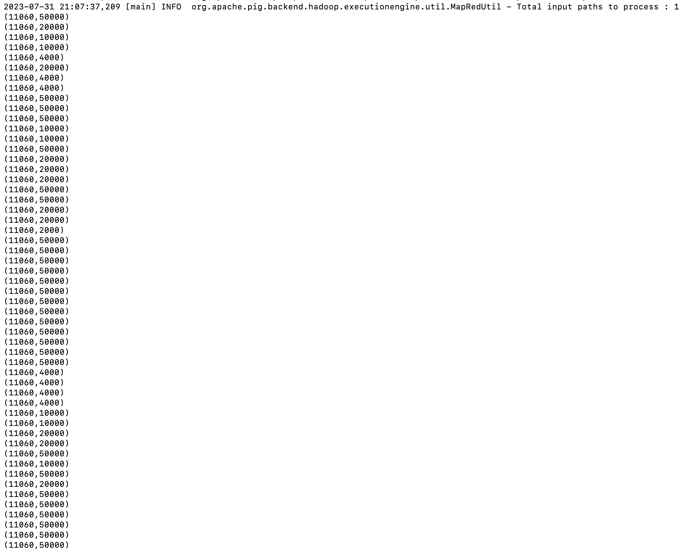

Using DESCRIBE

DESCRIBE Visibility_Distance;

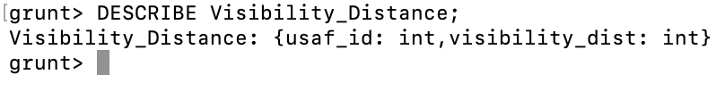

**Using Filter:**

filtered_records = FILTER Visibility_Distance BY usaf_id != 999999 AND visibility_dist is not null;



Using GROUPBY:

grouped_records = GROUP Visibility_Distance BY usaf_id;



DUMP grouped_records;

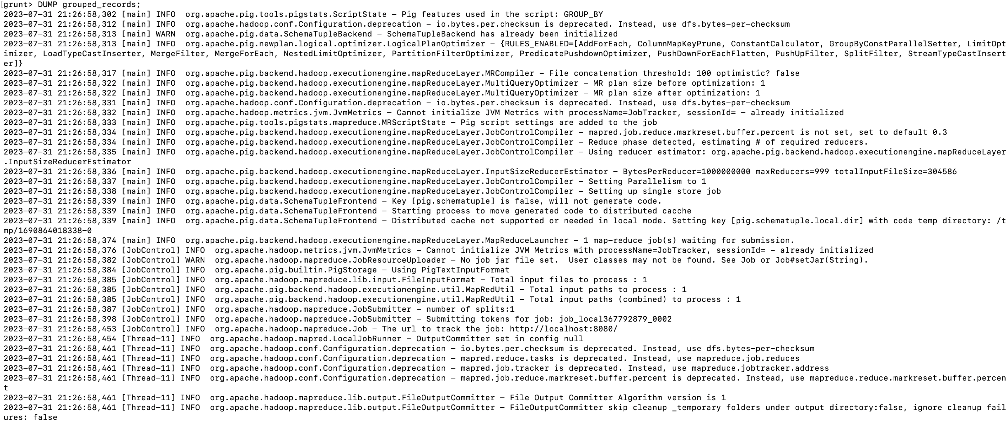

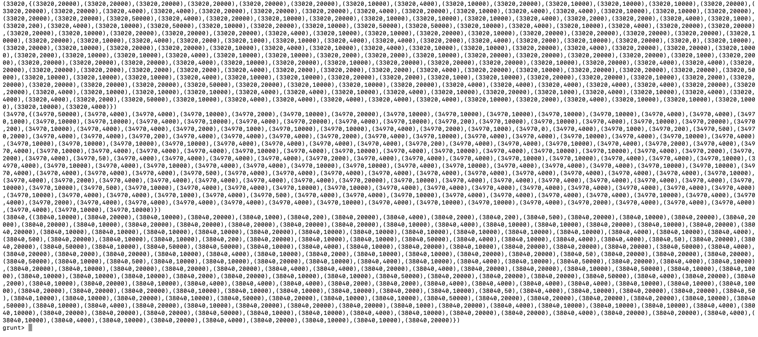

Calculating the visibility range using min and max using FOREACH:

Visibility_Range = FOREACH grouped_records GENERATE group AS usaf_id, MAX(Visibility_Distance.visibility_dist) - MIN(Visibility_Distance.visibility_dist) AS visdist_range;



DUMP Visibility_Range;

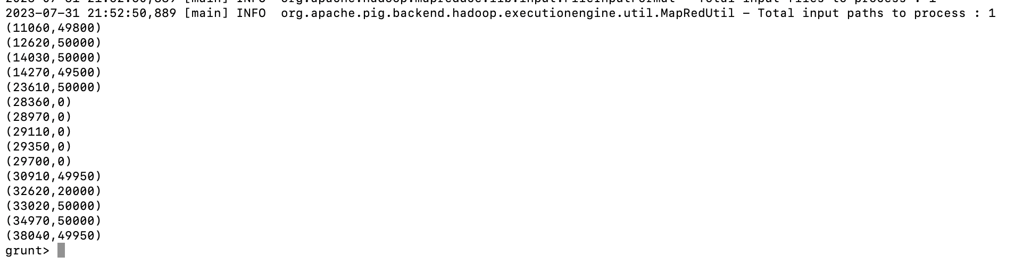

ILLUSTRATE Visibility_Range;

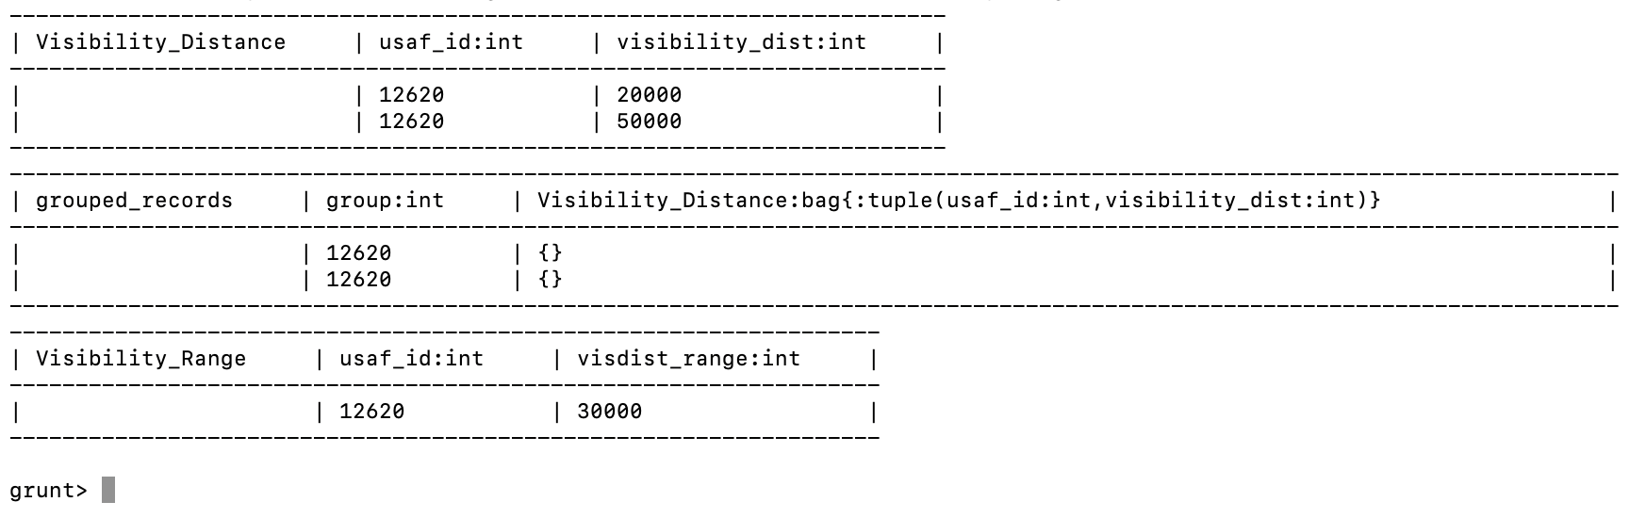

Load the text file into Hive and get the average *visibility distance* for each USAF weather station ID.

Initiate hive:

hive

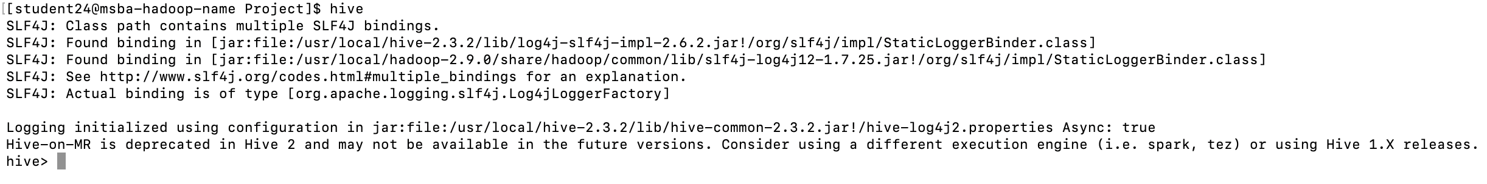

Creating table:

DROP TABLE IF EXISTS VisDist_St24;

CREATE TABLE VisDist_St24 (usaf_id INT, vis_dist INT)

ROW FORMAT DELIMITED

FIELDS TERMINATED BY '\t';

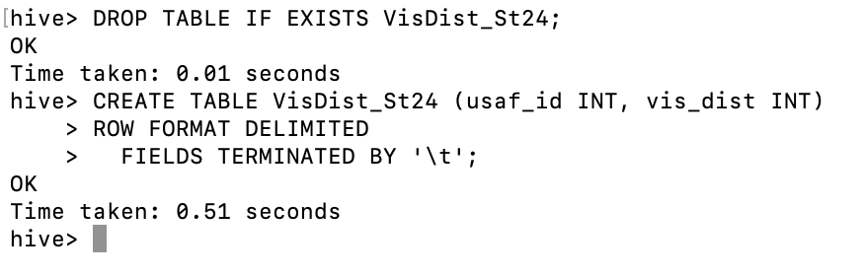

LOAD DATA LOCAL INPATH 'Part3_ProjectOutput.txt'

OVERWRITE INTO TABLE VisDist_St24;

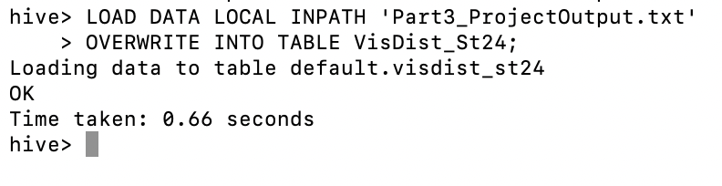

SELECT usaf_id, AVG(vis_dist)

FROM VisDist_St24

WHERE usaf_id != 999999 AND vis_dist != 999999

GROUP BY usaf_id;

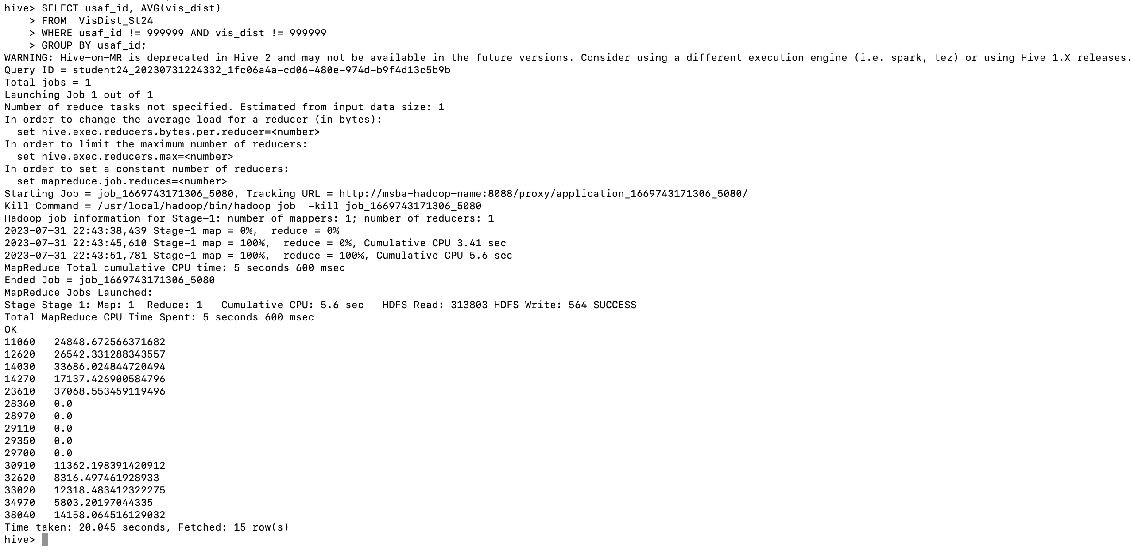

**You need to turn in:**

**1)** Part 1:

a. *if you are using JAVA to develop the Mapper and Reducer applications:* the three java files (mapper, reducer and main);

b. *if you are using Hadoop streaming jar and developing two python programs (mapper python file and reducer python file)*: the two python files (mapper and reducer);

c. *if you are using mrjob library and developing one python program with two functions:* the python file (with the mapper and reducer functions);

2) Part 2: the python program you developed;

3) Part 3: refer to Part 1; and the text file created;

**4)** the commands from converting java files into a Jar file to running the Jar file in Hadoop, or the commands to execute the python files in Hadoop and in Spark, all commands in Pig and Hive;

**5)** the step by step commands and screenshots of solutions from all the parts;

The original dataset for this project is available on Blackboard.